**CSCW-415: Software Quality and Metrics**

**Labs**

**Labs 5 and 6: Code Size (Lines of Code: LOC)**

For these labs we will be using a tool; “SourceMonitor” <https://www.campwoodsw.com/sourcemonitor.html>

Students need to install, understand, and read help of “SourceMonitor”.

Students need to give input, to SourceMonitor, many java, c/c++, and html code files and **analyze** the results. Students need to measure/analyze these source code files by changing multiple parameters; for example; blank lines, comments, comments on multiple lines, keywords, new methods (many), decision statements (if/else) loops, etc. Furthermore, they need to compare the results achieved through this tool with the results they will manually calculate (inspection). They also need to write a **summary** of what they have analyzed/measured.

**Students need to answer the following questions in their short reports:**

1. Write what measurements/tests you are going to perform? (e.g. code size etc. see other types of measurements you can perform, in the help section of SourceMonitor)
2. Which programming language source code files you have tested?
3. How many files you have tested? (for each programming language)
4. What changes (e.g. changing parameters as described above) you made in each file after first test?
5. What was the result of tests after changes?
6. Presentation of results in tabular and graphical formats.

**Notes:**

1. Students are required to work in groups.
2. Students can use their existing programs also (which they have already developed in other classes as assignments)

**Introduction:**

**SourceMonitor** is a tool that measures and records source code metrics (i.e. to know what is inside a body of code). It also preserves these counts and provides overviews of a project's history. SourceMonitor is a tool for coders and their supervisors. It is intended for use by programmers as they write code, to expose to them information about the code they are creating. Given this information, they have an opportunity to improve the way they work, the tools they use and ultimately the quality of the code they write. SourceMonitor is a tool for programmers who work in the 32 bit or 64 bit Windows world; Windows XP, Windows Vista, or Windows 7. SourceMonitor can parse only plain ASCII text files. The goal of SourceMonitor is to provide you with a quick overview of the **size and complexity of your code**. (Source: Help Topics in SourceMonitor)

**Step 1:**

Download it from here: <https://www.campwoodsw.com/SM/SMSetupV3516.exe>

**Step 2:**

Install it and start the SourceMonitor.

**Step 3:**

Create a folder and add different .java (or c/c++/html/etc.) files there. These files would be used for measuring/testing code size etc.

**Step 4:**

Create Project as described below.

**Step 5:**

Create a new checkpoint as described below. (The dialog box in this step will help you to select directory in which you have added .java (or c/c++/html/etc.) files).

After clicking OK button, you will see the project window and different results.

**Note:** Save results in screenshots so that it can be added in report. (for example like given below). By right clicking in “project view” window you can use extra menu options for more results.

**Some result screenshots:**

A view of project window:

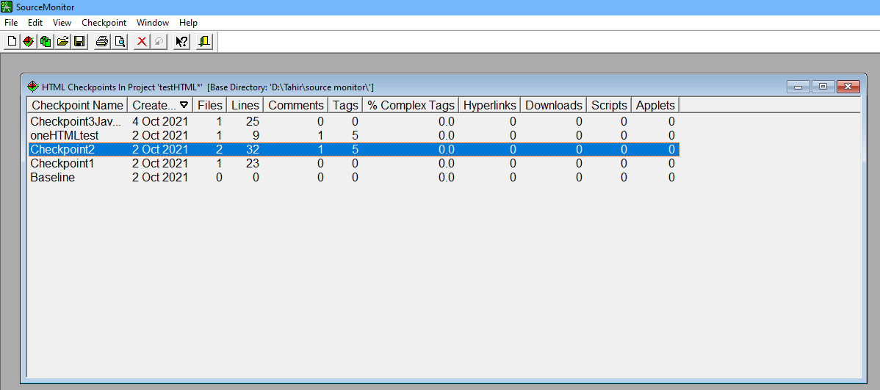

Try to get the results for different methods metrics: (like given below)

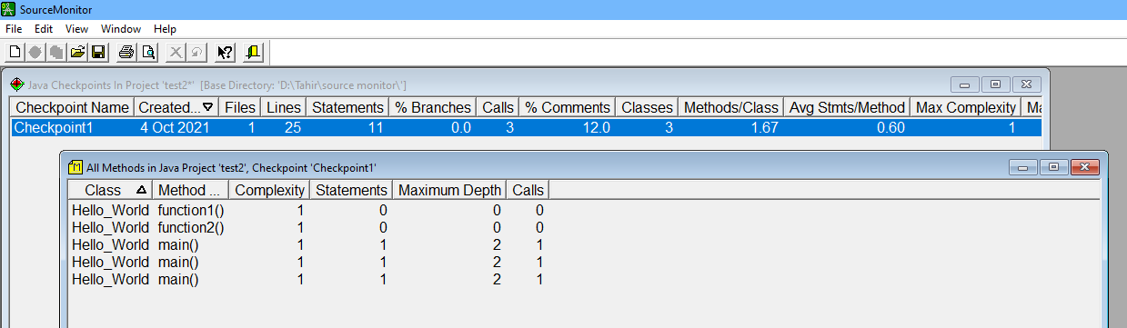

After adding files in SourceMonitor and calculating the checkpoint, display also the “Metrics Summary” like this (below):

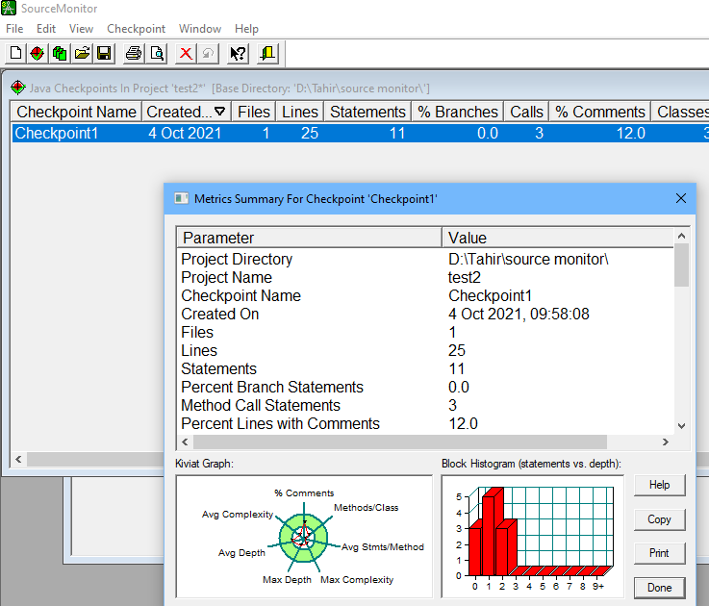

**Optional material:**

For these labs students can also use other tools (Google: tools for lines of code). You will get many tools. One of them is SLOCCount.

**SLOCCount** (pronounced "sloc-count") is a suite of programs for counting physical source lines of code (SLOC) in potentially large software systems. Thus, SLOCCount is a "software metrics tool" or "software measurement tool". SLOCCount was developed by David A. Wheeler, originally to count SLOC in a GNU/Linux distribution, but it can be used for counting the SLOC of arbitrary software systems. SLOCCount can count physical SLOC for a wide number of languages. SLOCCount has some report-generating tools to collect the data generated, and then present it in several different formats and sorted different ways. The report-generating tool can also generate simple tab-separated files so data can be passed on to other analysis tools (such as spreadsheets and database systems).

To use SLOCCount on Windows, you need to first install Cygwin.

**Install Cygwin** [**https://cygwin.com/install.html**](https://cygwin.com/install.html)

To run on Windows, you have to install Cygwin first to create a Unix-like environment for SLOCCount.

**Download and install Sloccount from here:** [**https://dwheeler.com/sloccount/sloccount-2.26.tar.gz**](https://dwheeler.com/sloccount/sloccount-2.26.tar.gz)

Then copy it in: C:\cygwin64\home\”user name” (replace “user name” with the name of your Windows account)

**For further information: read the sloccount user guide**

[**https://dwheeler.com/sloccount/sloccount.html**](https://dwheeler.com/sloccount/sloccount.html)